

**Trường Khoa học Tự Nhiên TP.HCM**

Trung tâm Đạo tạo Quốc Tế - ITEC

**Project Management**

**Mobile demo tools**

**Lecturer: Lâm Quang Vũ**

**Group 10**

**Member:**

**Name:** Trần Long Sơn **– Student ID:** 1259033 **– Email:** [1259033@itec.hcmus.edu.vn](mailto:1259033@itec.hcmus.edu.vn)

**Name:** Nguyễn Nguyên Thiên **– Student ID:** 1359038 **– Email:** 1359038@itec.hcmus.edu.vn

**Name:** Lâm Minh Triết **– Student ID:** 1359035 **– Emai:** 1359035@itec.hcmus.edu.vn

**Name:** Trần Đoàn Hải Phong **– Student ID:** 1159032 **- Email:** [1159032@itec.hcmus.edu.vn](mailto:1159032@itec.hcmus.edu.vn)

1. **Introduction**

This document was created in order to give a brief description about Project Management Games . In this document , we try to put everything that we hint to do for the seminar.

Group:

Name: Group 3.

Member:

Trần Long Sơn – [1359037@itec.hcmus.edu.vn](mailto:1359037@itec.hcmus.edu.vn)

Nguyễn Nguyên Thiên - [1359038@itec.hcmus.edu.vn](mailto:1359038@itec.hcmus.edu.vn)

Lâm Minh Triết - [1159032@itec.hcmus.edu.vn](mailto:1359035@itec.hcmus.edu.vn)

Trần Đoàn Hải Phong - [1359037@itec.hcmus.edu.vn](mailto:1359037@itec.hcmus.edu.vn)

Project Management:

Responsibilities: Find some simulation tools which can be used online and offline for practices.

Others: Manage what we found and make a comparison to give audiences an overview.

1. **Tools**
2. [**Vysor**](https://www.youtube.com/watch?v=qAHTini67GA)
3. **Introduction**

* 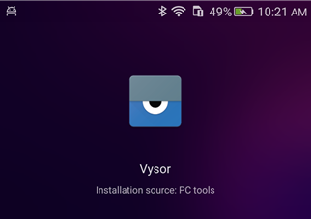**Vysor** is an extension for Google Chrome; therefore, people can fully control their Android device from any computer on the familiar Google Chrome browser.
* After installing **Vysor,** the user can see live screens of their phone on the PC in real time, and can operate completely on the device without holding it.
* There are two type of **Vysor**:
  + Free version: you just only can Mirror, control Android and screenshots.
  + Pro version: which allow you to use all functions and its cost depend on your options.

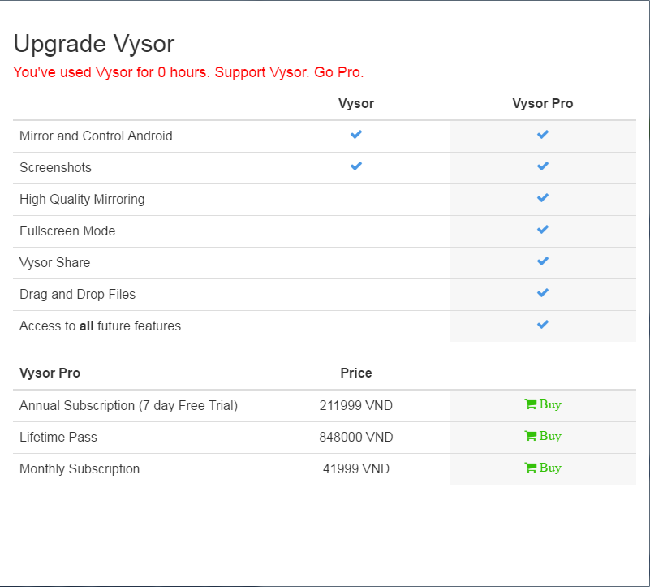

1. **How to sign up?**

* On your computer.
  + Launch the browser Google Chrome.
  + Click on the menu bar on the top of the web browser and select ‘More tools’ then choice ‘Extensions’.
  + Type ‘Vysor’ into search box and download it to your PC. After installing, the icon will appear on the main menu as the picture below.

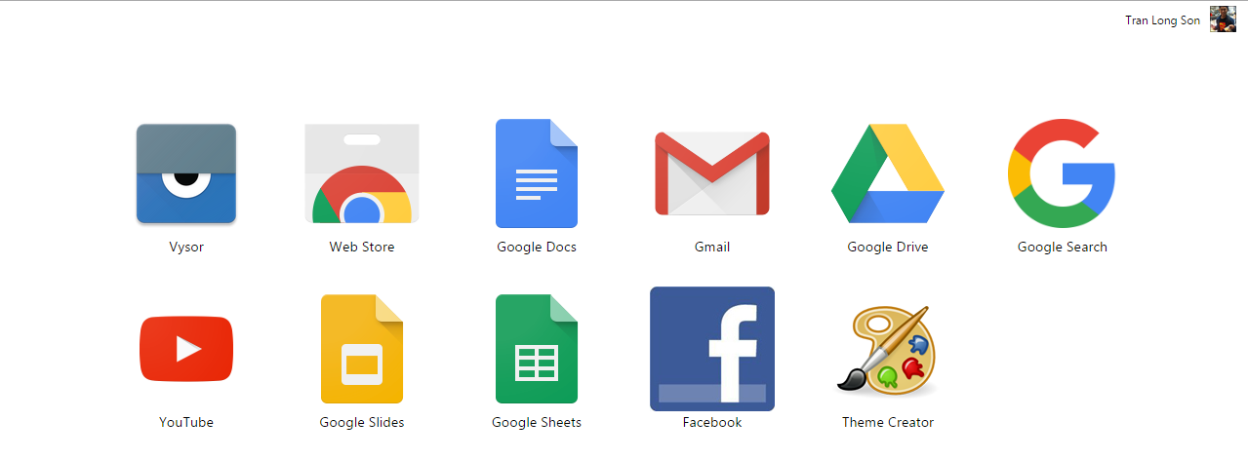

* Launching the app and click ‘Find Devices’.
* On your Android device: